**Name:_____________**

**30 Second Indoor Challenge**

How many of each activity can you do in 30 seconds? Record it on the form.

#_____________

#_____________

#_____________

4# High Knee Jumps 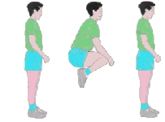 #______________

30 seconds Yes___ No ___

30 seconds Yes___ No ___

#_____________

30 seconds Yes___ No ___

#_____________

#_____________